Reinforcement learning – assignment 1
Tomer Ashkenazy – 318961265
Ohad Sheelo – 318473816
Section 1:
- Value Iteration requires complete knowledge of the transition dynamics $p(s^{'},r∣s,a)$in order to compute the Bellman optimality backup over all possible next states.
In a model-free environment these dynamics are unknown, so the agent cannot compute the required expectations and therefore cannot run Value Iteration.
Thus, VI is not applicable because it depends on a full model, while model-free methods rely only on sampled interaction.
- Model-free methods avoid the need to know the transition dynamics $p(s^{'},r∣s,a)$because they learn directly from sampled experience tuples $(s,a,r,s^{'})$.
Instead of computing expectations over all possible next states, they use sample-based updates—such as Monte Carlo returns or Temporal-Difference (TD) bootstrapping—to approximate the true $Q$-values.
This allows model-free algorithms to improve value estimates using only the transitions the agent actually observes, without ever constructing or using a transition model
- SARSA is on-policy, meaning it updates Q-values using the actual next action chosen by the agent’s behavior policy (including ε-greedy exploration).
Q-learning is off-policy, meaning it updates Q-values toward the greedy action ${max⁡}_{a^{'}}Q(s^{'},a^{'})$, regardless of what action the agent actually took.
Thus, SARSA learns the value of the current exploratory policy, while Q-learning learns the value of an optimal greedy policy, even while behaving non-greedily.
- Acting greedily prevents exploration, so the agent may converge to a suboptimal policy because it never tries alternative actions.
Using decaying ε-greedy ensures sufficient exploration early on to discover better long-term strategies, and gradually shifts toward exploitation after the agent has learned a good estimate of the Q-values.
This balance prevents the agent from getting stuck due to incomplete information.

Hyper-parameters used in the final model:
Hyper Parmeter | value
Learning rate | 0.1
Epsilon | 1
Epsilon decay | 0.999
Min epsilon | 0.1
Gamma | 0.99
Episodes | 5000

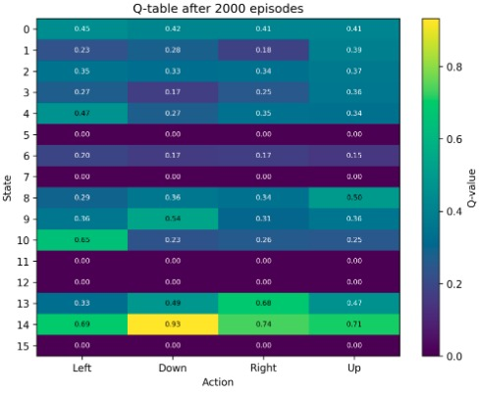
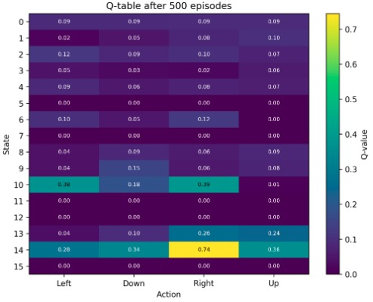
Q-value tables:
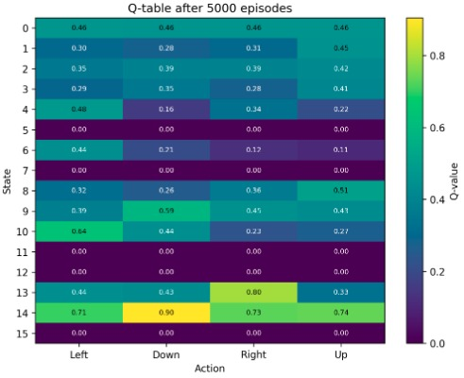

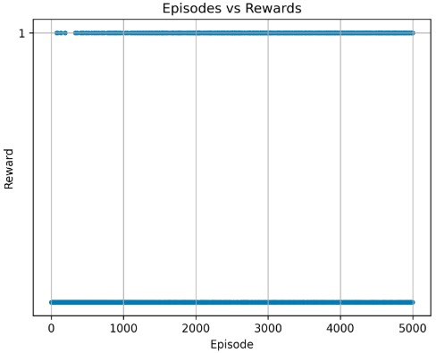
episode vs. reward plot:

Average number of steps plot:
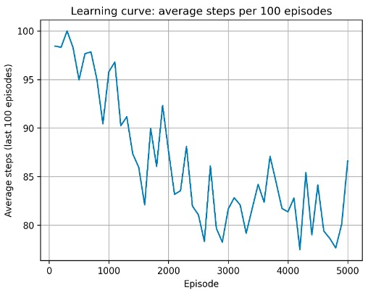

Section 2:
- Random sampling is used to break the strong correlations between consecutive transitions in a trajectory, since SGD assumes independent samples. If we were to train on sequential samples, their gradients would point in nearly the same direction, causing instability, overfitting to recent states, and poor learning.
Random sampling also prevents the network from “forgetting” past experiences by regularly reintroducing older transitions, which stabilizes learning and improves generalization.
- Using an older network to compute the targets prevents the non-stationary target problem, where both the prediction and the target change at the same time and make learning unstable.
By freezing the target network for several steps, the Q-target becomes much more stable, allowing the main network to learn toward a slowly moving objective instead of chasing a changing target.
This greatly improves convergence and training stability in DQN.
Hyper-parameters used in the final model:
Hyper Parmeter | value
Learning rate | 1e-4
Batch size | 128
Epsilon | 1
Epsilon decay | 0.995
Min epsilon | 0.1
Gamma | 0.99
Episodes | 2000
Memory capacity | 50000
Target update frequency | 50
State dimension | 4
Action dimensions | 2
Reward goal (100 episodes average) | 475

architecture
3 layers | 5 layers
[state_dim,64,64,64,action_dim] | [state_dim,64,64 ,64,64,32,action_dim]

Grid search:
- Epsilon decay: we tried lower epsilon decay such as 0.99, but we found that lower epsilon decay makes the model stop exploring in an early stage, so higher epsilon rate forces the model to continue exploring and typically find better policies.
- Batch size: small batch size didn’t yield sufficient results so we use 64 and 128
- Fully connected layer with high dimensionality (128,64) yielded better results.

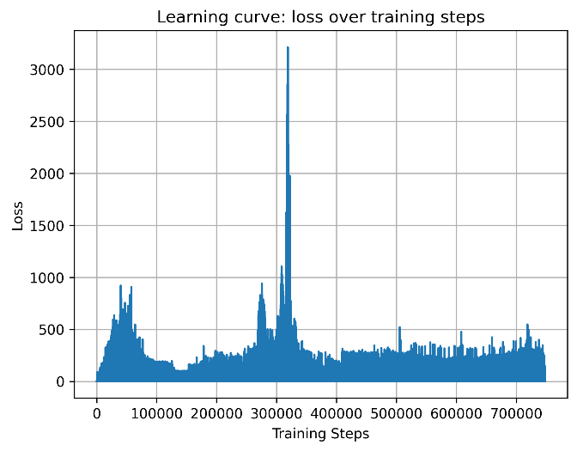
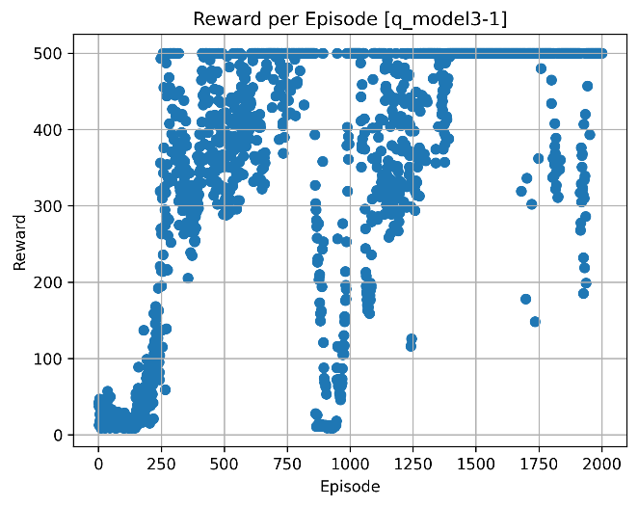
3 layers – reward per episode and loss per step:
Last 100 episodes reward >= 475: episode 600

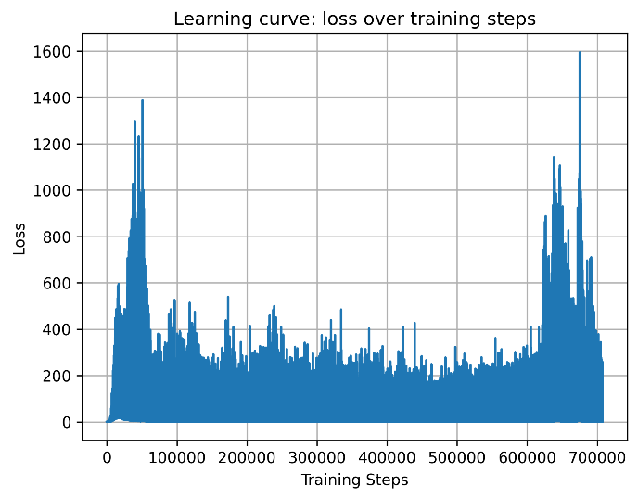
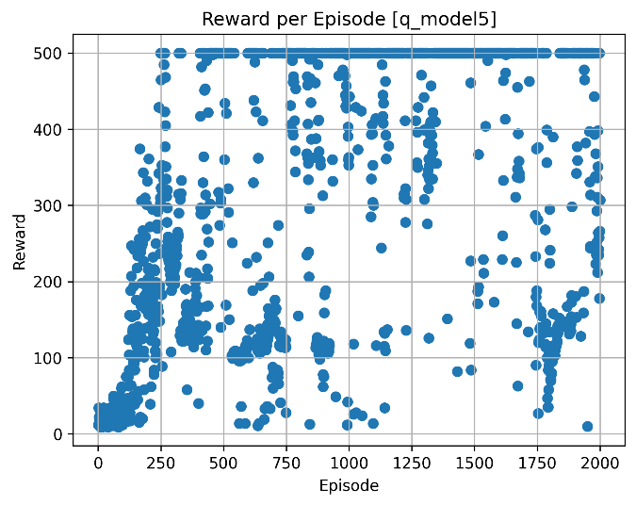
5 layers – reward per episode and loss per step:
Last 100 episodes reward >= 475: episode 800

Section 3:
In this section, we attempted to improve our network using a method learned in class — the dueling network architecture. We expected this approach to enhance performance because separating the value and advantage functions can help the model learn more effectively. Some actions taken in a state may cause the pole to fall to the opposite side because the chosen action is too abrupt or rushed. We believed that the dueling architecture could help mitigate this issue by better distinguishing the value of a state from the advantages of specific actions, thereby reducing the likelihood of such destabilizing actions.
Hyper-parameters used in the final model:
Hyper Parmeter | value
Learning rate | 1e-4
Batch size | 6
Epsilon | 1
Epsilon decay | 0.9
Min epsilon | 0.1
Gamma | 0.99
Episodes | 2000
Memory capacity | 50000
Target update frequency | 50
State dimension | 4
Action dimensions | 2
First three fc hidden layers | 64
Advantage layer | 32
Value layer | 32
Reward goal (100 episodes average) | 475

Comparison with section 2:
The dueling network also achieved the goal of suppressing 475 reward average in 100 episodes, But the training took us less tries and hyperparameter tuning to achieve the reward goal. The dueling network also took less episodes to converge.

Section 3 training plots:
loss per step
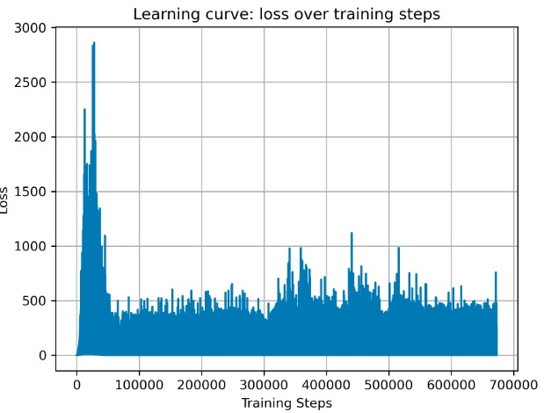

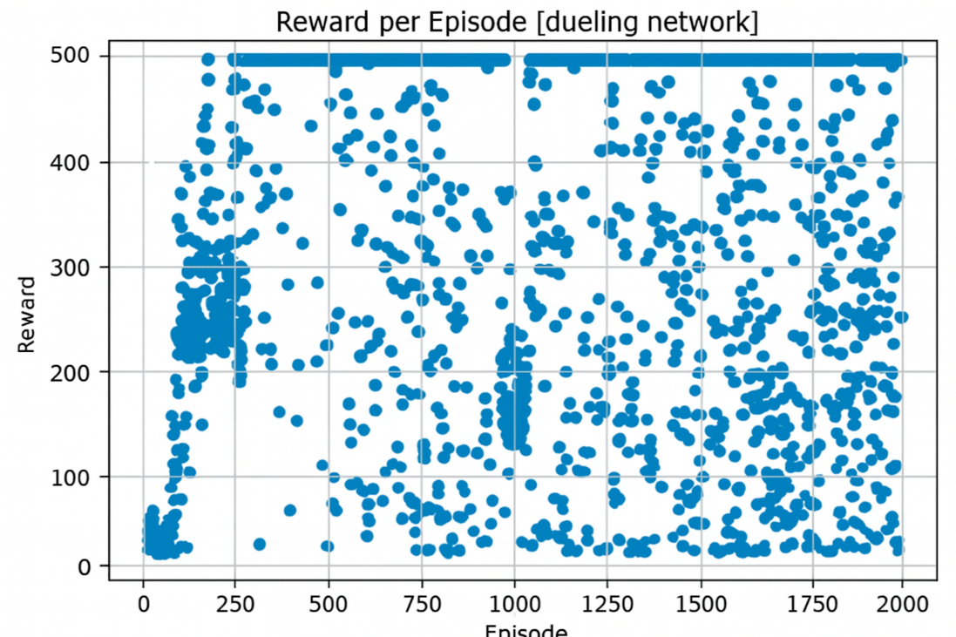
Reward per episode

Last 100 episodes reward >= 475: episode 500

